# Hope - Relying On God’s Help When We Are Worried

## Those people who know they have great spiritual needs are happy. The kingdom of heaven belongs to them.

This activity offers pupils the opportunity to think and pray about things that worry them and ask for God’s help.

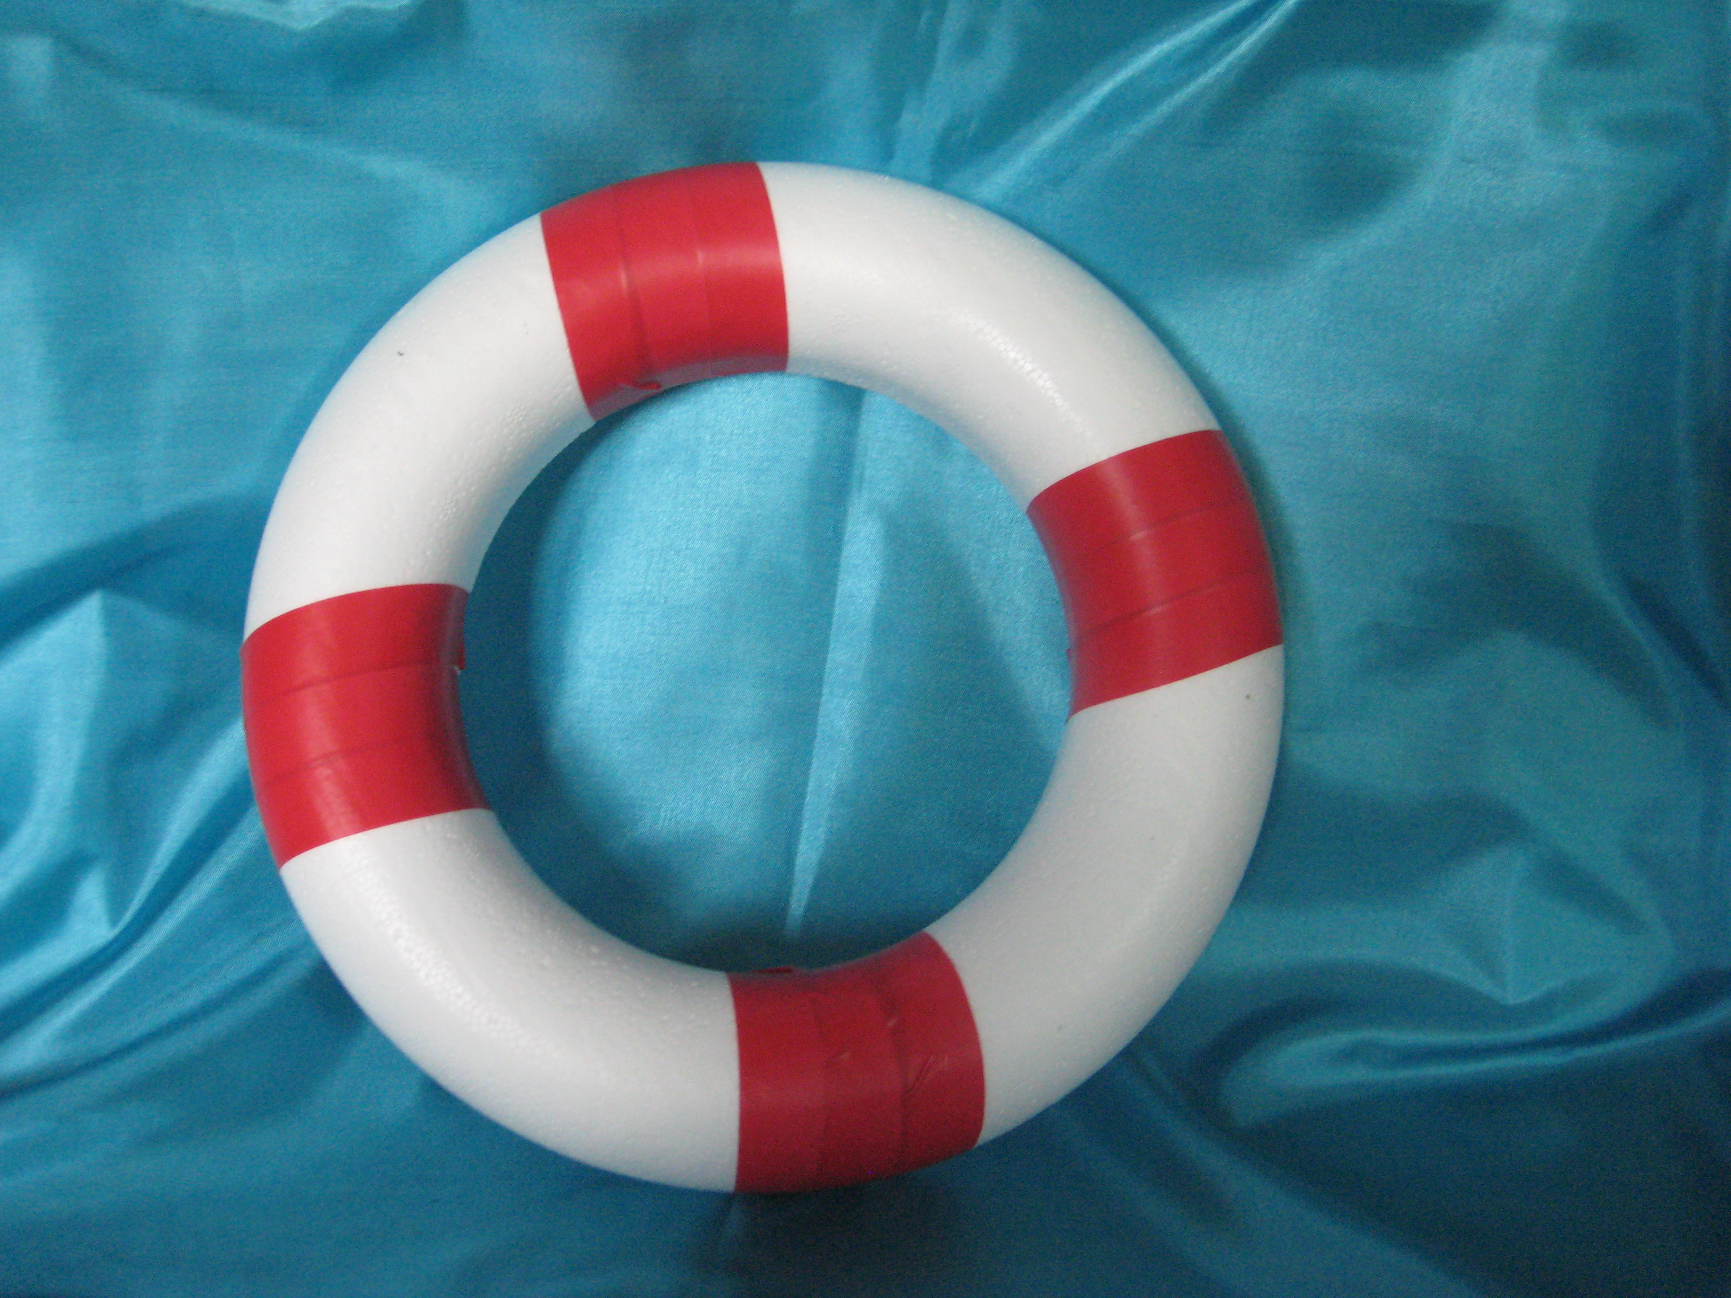

Equipment:

* This activity needs to be set up away from the quieter prayer stations with space around it.
* A set of skittles, the school may well have these. *These could be made from 1litre milk cartons filled with sand or water*
* Labels on the skittles. *Ideas below*
* Quoits with coloured tape stuck on to look like life rings, the school may well have these. *These could be made from polystyrene circles or even paper plates with the centre cut out.*
* Life ring cards – one per pupil. *Template below*
* Pencils
* A large attractive bowl or basket

Instructions:

This activity requires adult supervision for the practical element, and adult support if pupils wish to talk about their worries.

Stick the labels on the skittles and lay them out on the floor with plenty of room around them.

The quoits are meant to look like a life ring. God can help us with the things that worry us, like a life ring rescues people.

Pupils read the worries written on the skittles and think about things that worry them.

Pupils take a quoit and throw it over the worry that they want God’s help with.

Or you could not have skittles but simply have cards with the worries written on and place the life rings on the cards.

They could then write or draw their worry on a card and put the card into the bowl.

Adults should be aware that pupils may want to talk about their worries. This activity could lead to some safeguarding issues being disclosed. Adults need to be clear about the safeguarding procedure agreed with the school for the Prayer Space.

**Relying On God’s Help When We Are Worried**

When people are in difficulty in water, they are rescued by someone on the land throwing them a life-ring to help them float.

Read the worries that are stuck on the skittles, maybe one of them is something that bothers you.

Throw the life-ring over the skittle to remind you that God wants to help you.

Write or draw your worry onto one of the life-ring cards. Then put the card into the dish as a sign that you have asked God to help you with that worry.

You may want to talk to an adult you trust about the things that are worrying you.

|  |  |  |
| --- | --- | --- |
|  |  |  |
|  |  |  |

Possible labels for the skittles

|  |  |  |
| --- | --- | --- |
| **School work** | **Friends** | **My family** |
| **Illness** | **Moving house** | **Moving school** |

More possible labels for the skittles

|  |  |  |
| --- | --- | --- |
| **Bullying** | **Being left out** | **Failure** |
| **Exams or Tests** | **My Future** | **Pets** |