# Humility - Putting Others First

## Those who are humble are happy. The earth will belong to them.

This activity offer pupils the opportunity to think and pray about how they can put others’ needs before their own.

Equipment:

* 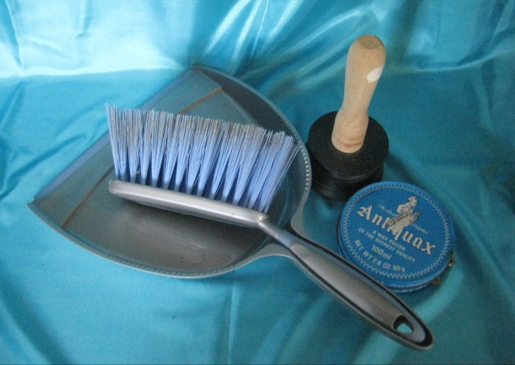A display of cleaning tools. Such as washing up bowl, washing up brush, car washing sponge, duster etc. A toilet brush (brand new) elicits quite a response! *These need to be new or very clean with no cleaning products included*
* A display of pictures of people doing unpleasant jobs and helping others.
* Several sets of action cards.
* You could have lots of small action cards for pupils to take away as a reminder.

Instructions:

Look at the cleaning materials and the pictures of people doing some of the dirty and smelly jobs. Look at the pictures of people helping others.

For EYFS you could put out some plastic plates and cups for them to wash up.

Explain to the pupils that humility is thinking that others’ needs are more important than ours. Not pushing ourselves to the front of a line, or always being the person who chooses the game, or video or activity. Instead helping other people to feel good about themselves, helping others to feel special.

Look at the ideas of things that you could do to put others first to make them feel special. Choose one of those ideas to go and do today or tomorrow.

It maybe something you can do at home, at school or in your community.

The adults should be aware that some pupils may have very low self-esteem and need encouragement that they themselves are valued.

**Humility - Putting Others First**

Look at the things that people use to do cleaning. Look at the pictures of people doing some of the dirty, smelly jobs, or helping others. Would you choose to do those jobs?

Humility is putting other people first and yourself at the back of the line, recognising that you are not the most important person in the room.

Have a look at some of the suggestions for how to make others feel special. Choose one that you will do today or tomorrow.

Primary suggestions

|  |  |
| --- | --- |
| Chat with someone outside your usual friendship group today. | Surprise someone today. In a nice way. |
| Say something nice about someone behind their back. | Send a message, picture or card to an adult who is important to you. |
| Say thank you to one of the adults in school today.  Remember to include the people who don’t work in a classroom. | Offer to help an adult at home or at school today. |
| Thank the person who cooks your food today and offer to help clear up. This mighty be at home or at school. | Compliment someone on their work today |

Secondary suggestions

|  |  |
| --- | --- |
| Talk to someone outside your friendship group today. | Say something nice about someone behind their back. |
| Contact an adult in your family who you don’t see very often. Send a message or photo. | Find out about the life of someone your age in a poorer country. Imagine what it would be like to swap. |
| Reply warmly to a post on social media from someone you haven’t replied to for a while. | Make something to give to someone else. Bake, draw, photograph. |
| Create a playlist for a friend or relative and send it to them. | Say thank you to someone who runs a group or club that you attend. |