# Justice – Standing Up for Those Who Are Being Treated Unfairly

## Those who want to do right more than anything else are happy.

## God will fully satisfy them.

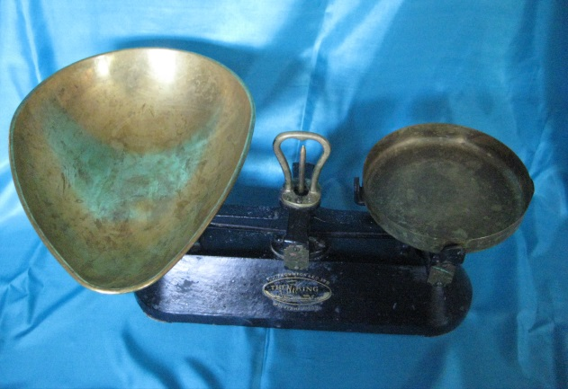

This activity offer pupils the opportunity to think and pray about issues of fairness and social justice.

Equipment:

* Set of balance scales. The bucket balance scales that can be found in infant classes are ideal
* Some blocks or weights with injustices written or stuck on them. Examples provided
* Small pieces of paper and pens
* Pictures and case studies of social justice issues here are some places to find these. Choose case studies to suit the age of the pupils.

[Christian Aid](https://www.christianaid.org.uk/homepage)

[Unicef Rights of the Child](https://www.unicef.org.uk/what-we-do/our-uk-work/)

[Tearfund](https://www.tearfund.org/about_us)

Instructions:

For this activity you need 2 or 3 examples of social justice issues. There are some suggested websites which contain examples you could use. Consider the age of the pupils when choosing case studies. Some of these websites include short videos which may be useful as part of this prayer station.

Sometimes things are not fair. Maybe you have felt that you have been treated less well than someone else in your family or class. Encourage the pupils about what they have felt was unfair.

Some people in the world are treated unfairly in a way that makes a big difference to their lives. Have a look at some of the examples on this display. How do the pupils feel about what they have seen?

Pupils may need the concept of scales as an image of justice explained to them.

Look at the scales, one side is weighted down with things that aren’t fair. On a piece of paper write a thought, prayer or action that you will do to help bring fairness to a situation. This could be local or global. There are some ideas which could be used as thought starters below.

With very young children this will be about treating people they know fairly. Will their papers balance the scales of injustice?

**Justice – Standing Up For Those Who Are Being Treated Unfairly**

Some people in the world are treated unfairly in a way that makes a big difference to their lives. Have a look at some of the examples on this display.

Scales are often used as a symbol of justice. Look at the scales, one side is weighted down with things that aren’t fair.

On a piece of paper write a thought, prayer or action that you will do to help bring fairness to our world. Together will you all be able to balance the scales with your thoughts, prayers and actions?

Injustice labels for blocks on the scales

|  |  |  |
| --- | --- | --- |
| Lack of clean water | Lack of food | No education |
| No home | Unfair pay | Lack of medicine |
| No dignity | No hope for a better future | No one to care |

Ideas for actions to fight injustice, could be used as labels on the prayer station

|  |  |  |
| --- | --- | --- |
| Compassion | Fair Trade | Campaigning |
| Volunteering | Fair Pay | Prayer |
| Fundraising | Free Education | Giving |