# Peace - Bringing Peace to the World

Those who work to bring peace are happy. God will call them his children

This activity offers the pupils the opportunity to think about or pray for situations of conflict or war.

Equipment:

* 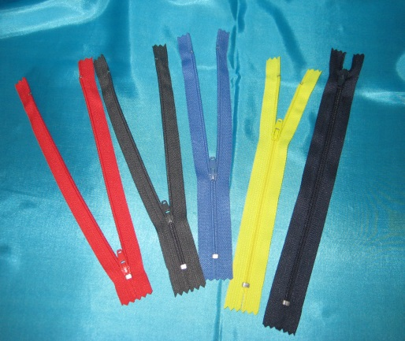A large world map - *There may well be one in school. If you need to buy one the cheapest source is as a shower curtain sold by several companies online.*
* And / or a globe
* You may wish to include some pictures of places devastated by fighting
* A basket of zips. - *These are expensive to buy individually but can be bought cheaply in bulk online.*
* A cross
* This activity could be set up on the floor

Instructions:

This activity offers pupils an opportunity to think about and /or pray for situation where there is conflict. This may include large scale conflicts or wars. Or it may be conflict between people the pupils know.

Team members should be alert to children wanting to talk about conflict between family members or friends.

Have a basket of unzipped zips available.

Pupils are encouraged to take a zip and as they do it up watch the teeth interlock together. As they pull the two sides together, they can think about or pray for a situation of conflict and how the two sides could make peace.

Think about or pray for the people who are trying to bring peace.

When they are ready, they can either lay the closed zip on the world map over the place of conflict. Or lay their closed zip at the foot of the cross as a symbol of God bringing peace.

**Peace - Bringing Peace to the World**

Take an open zip, as you start to zip it up look at the way that the teeth come together.

Can you think of a place where people are disagreeing with each other or fighting?

It may be a war between countries or a disagreement between family or between friends.

Slowly do up the zip and watch the two sides coming together. As you do up the zip, think about, or pray for, the people who disagree or the fighting you have chosen.

Think about or pray for the people who are trying to bring peace.

When you are ready put your zip by the cross as a sign of your thoughts or prayer.

Or you may like to put the zip on the place on the map that you have prayed for.