How to print/download your responses to
Session 1 Preparation tasks

- Go to Leadership module on the learning portal

- Click on ‘Session 1’ button:
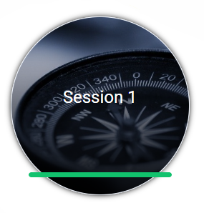

- Click on ‘Session 1 Preparation’ button:
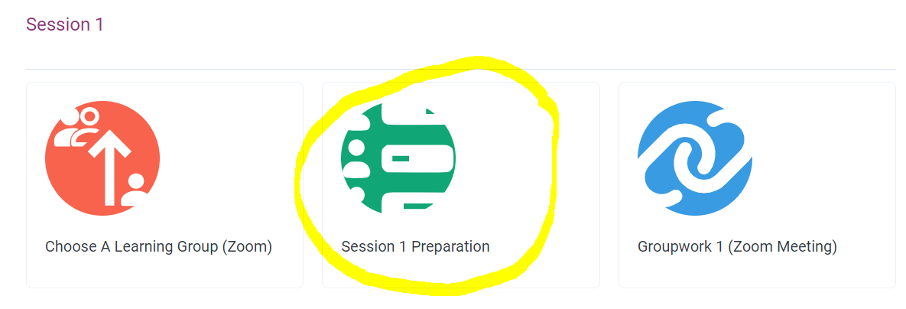

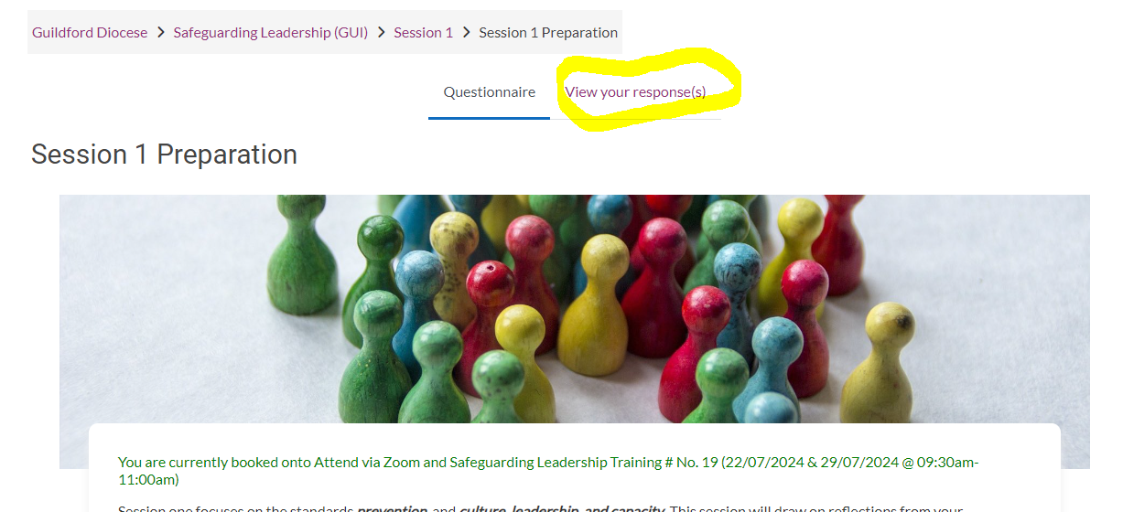
- Click on ‘View your responses’:

- Click on the printer icon:

- Right click anywhere on the page and left click on ‘Print’ option:

- Choose either ‘Print’ to print your responses off or ‘Save as PDF’ if you want to download them to your computer:

