Safeguarding in our Parish
Our Parish Safeguarding Officer is

Diocesan Safeguarding Team

safeguarding@cofeguildford.org.uk, Tel. 01483 790379

Normal working hours: Monday – Friday 9am-5pm

Safe Spaces, an independent service supporting survivors of church-related abuse. Telephone: 0300 303 1056 (answerphone available outside of opening times) Email safespaces@victimsupport.org.uk WebChat via the Safe Spaces website

For all emergencies call 999

The Multi-Agency Safeguarding Hub (MASH)
Children’s Service social workers, Adult’s Service social workers, health and police staff.
Hampshire Children 0300 555 1384 (office hours)
0300 555 1373 (out of hours)
Adult 0300 555 1386 (office hours)
0300 555 1373 (out of hours)

Domestic Abuse
Hampshire 03300 165112
24hr National Domestic Abuse Helpline 0808 2000 247
DeafHope (BSL) text: 07970 350366
Childline 0800 1111

National Society for the Prevention of Cruelty to Children
NSPCC 0808 800 5000 or help@nspcc.org.uk
NSPCC Sign Video link nspcc.org.uk/about-us/contact-us

Samaritans 116123 or jo@samaritans.org
Modern Day Slavery Helpline 0800 0121700
Mental Health Crisis Helpline 0300 5000 101
Open 5.00pm - 9.00am Monday to Friday
24 hours cover at weekends inc Bank Holidays in East Sussex, Brighton and Hove

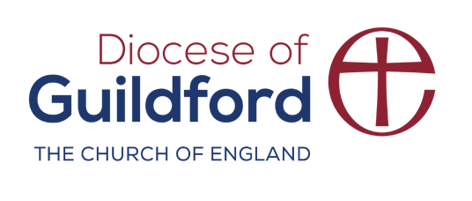
Stop it Now! 0808 1000 900 www.stopitnow.org.uk
cofeguildford.org.uk/safeguarding

