Teacher script: Thank You
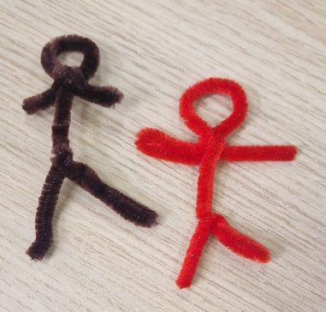
Sit the children in front of the teacher holding their pipe cleaner person. It’s important to allow some good pauses between sections, so that pupils are given plenty of time to think, reflect or pray.

You have thought of someone that you want to be thankful for. Someone who has been there for you or helped you during your time at primary school.

Take your pipe cleaner person.
- Hold your pipe cleaner person’s head. What did they say that helped you?
- Hold your pipe cleaner person’s hands. What did they do to help you?
- Hold your pipe cleaner person’s feet. Where did they go with you?
- With your thumb touch your pipe cleaner person’s body, where their heart would be. How did that person make you feel?

In your head bring up a picture of the person you are thankful for, you may like to quietly thank God for that person now.

You are going to take your pipe cleaner person back to school with you.

