# Wisdom - Thinking in God’s Way

## Those who are pure in their thinking are happy. They will be with God....

This activity offers pupils the opportunity to think and pray about their thoughts and attitudes towards other people.

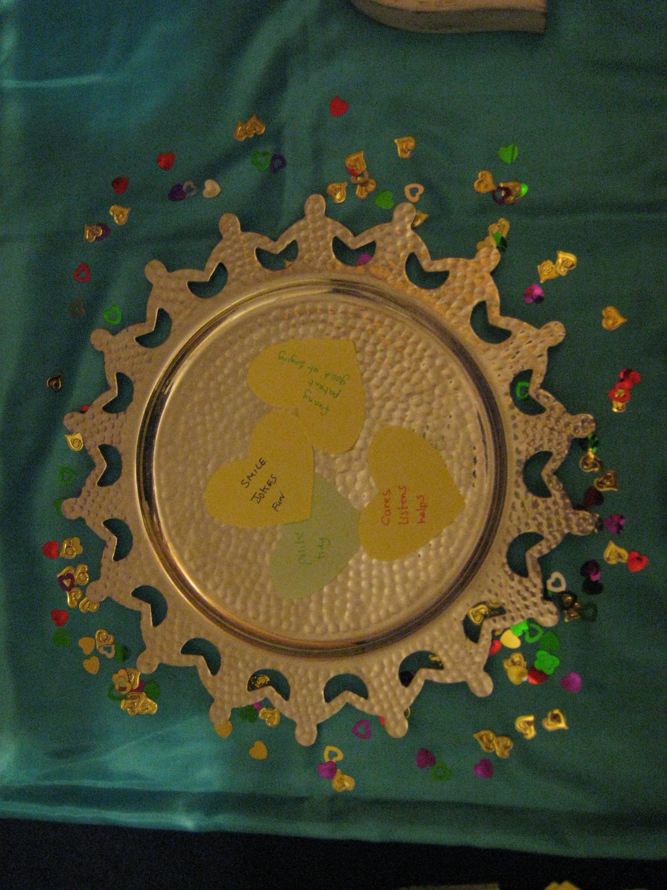

Equipment:

* Heart shaped pieces of paper or Post Its.
* Pens
* A large dish or plate.
* A plain tablecloth.
* Small hearts, enough for every pupil to take one. Table confetti works well

Instructions:

Spread the small hearts across the table with the dish in the middle. Put the paper hearts and pens around the edge. You may wish to have some cards with suggestions of positive qualities on the display. See attached ideas.

Encourage the pupils to think about their thoughts and attitudes towards other people. It’s hard to think kind thoughts, especially about people we find difficult: God can help us.

We can’t be best friends with everyone, that’s fine. There are some people who we find it hard to think positive things about. I wonder who that person is for you? It may be someone at home, someone in your family, someone at school or someone that lives near you. Help the pupils to think of just one person: there is no need to name that person out loud or on the heart shaped paper.

Think about that person and try to think of three positive / good things about them. Write those three things on a heart shape and put that shape in the dish. If the pupils are having difficulty draw their attention to the suggestions on the prayer station.

Remind them not to write any names on the heart.

You could ask: I wonder if you feel differently about them now you have thought about the good things about them?

If the pupils would like they can take one of the small hearts to remind them that God can help them to think about other people in His way. You may need to keep an eye on how many hearts they take, or only put a few out at a time. Young children find sparkles very attractive!

**Wisdom - Thinking in God’s Way**

It’s difficult to always think kind, positive thoughts about other people.

There are some people that we find it hard to think good things about. Who is that person for you? It maybe someone at home, someone in your family, someone at school or someone that lives near you.

Think about that person and try to think of three good things about them. Write those three things on a heart shape and put that shape in the dish. **Don’t write any names on the heart**.

Do you feel differently about that person now you have thought about the good things about them?

**Wisdom - Thinking in God’s Way**

If you would like, take one of the small hearts to keep with you as a reminder that God can help us think good things about other people. You could keep it in your pencil case, school bag or pocket.

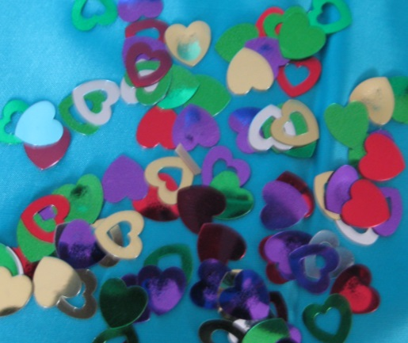

Ideas of positive qualities

|  |  |  |
| --- | --- | --- |
| Caring | Tidy | Funny |
| Good at …… | Good at running | Good at singing |
| Thoughtful | Loyal | Honest |

Ideas of positive qualities

|  |  |  |
| --- | --- | --- |
| Calm | Patient | Positive |
| Helpful | Peaceful | Good listener |
| Cheerful | Fun | Polite |